Title:
An in-silico assessment of the accuracy of transcutaneous CO₂ monitoring – Good enough to be the pulse ox of ventilation?

Authors:

Dustin Anderson-Bell MD
Jeanette Brown MD PhD
Ramkiran Gourripeddi MBBS MSc
? Ben Brintz
? Jason Ackrivo?
Brian W Locke, MD MSCI
Background:
Hypercapnic respiratory failure is a widespread and consequential problem with prognostic significance.^{1–6} However, the diagnostic gold standard of arterial blood gas (ABG) sampling requires expertise and has significant drawbacks to regular performance such as pain and complications including arterial injury, thrombosis, and blood stream infections.^{7,8} Such issues limit the role of ABGs in routine monitoring and screening for hypercapnia. Transcutaneous CO₂ monitoring (TcCO₂) offers a potential alternative unmarred by such issues, though its adoption has been limited by concerns that its ability to detect hypercapnia may be insufficient to warrant widespread clinical implementation and financial reimbursement.^{9,10} In the present simulation we aim to estimate the theoretical accuracy of TcCO₂ in detection of hypercapnia by applying reported agreement between TcCO2 and PaCO2 to a large dataset of arterial samples.

Methods:
The TriNetX network database (which provided access to electronic medical records (diagnoses, procedures, medications, laboratory values, genomic information) from approximately 115 million patients from 75 healthcare organizations) was accessed on 06/02/2023 for all encounters in which an arterial CO2 (PaCO₂) was obtained in order to obtain a real-word population of PaCO₂ values. Only the first PaCO2 used for the first calendar day of each admission was used. Data were subdivided into location of sampling including the Ambulatory setting (Amb), Emergency Department and Inpatient Wards (ED/Inp), and Intensive Care Unit (ICU).
Data from a meta-analysis by Conway et al¹⁰ were accessed to obtain mean PaCO₂-TcCO₂ bias and uncertainty (within- and inter-population disagreement). While Conway et al explicitly reported location-specific values for subgroups of ICU and ED/Inp populations, there was not a subgroup of ‘ambulatory’ patients. They did, however, report a ‘Pulmonary Function Test unit (PFT)’ from which we assumed a great enough degree of similarity to our Ambulatory group to justify valid application (ie that most ambulatory PaCO2 values in the TriNetX database were either done in the PFT unit or were similar enough to maintain validity).
A simulated TcCO₂ was then created for each TriNetX PaCO₂ using the setting-specific models derived from the data from Conway et al. Each simulated TcCO₂ was classified as True or False and Negative or Positive by comparing the presence of arterial hypercarbia (PaCO₂ ≥45mmHg) to that of TcCO₂ under two different definitions. The first classification scheme used a strict TcCO₂ hypercarbia threshold of ≥45mmHg. The second classification system applied more extreme boundaries of classification of TcCO₂ (normal: <40mmH; hypercarbia ≥50mmHg) in order to separately evaluate test characteristics for only those TcCO₂ values that are further from borderline classification. TcCO₂-PaCO₂ agreement was then used to estimate Sensitivity (Se), Specificity (Sp), and Negative and Positive Predictive Values (NPV/PPV). Multi-level modeling and Monte-Carlo simulation were used to account for mean bias, within-study variance, between-study variance, and uncertainty in each parameter estimate.

Results:
197,698 ABGs were included across all clinical settings (113,078 ED/Inpt, 66,704 ICU, and 10,456 Amb). Median age was 61 years (IQR 51, 74), 54.7% were male, and race was comprised of 64.5% non-Hispanic White, 14.3% Black, 5.4% Hispanic, and 1.9% Asian. Median PaCO₂ for all aggregated patients was 40.0 (IQR 34.0, 46.6). Prevalence of relevant comorbidities included 12.4% Obstructive Sleep Apnea (OSA), 11.5% asthma, 21.5% Chronic Obstructive Pulmonary Disorder (COPD), 22.4% Congestive Heart Failure (CHF), and 4.6% Opioid Use Disorder (OUD).
The proportion with PaCO₂ ≥ 45 mmHg was 26.5% (Amb), 30.1% (ED/Inp), and 31.7% (ICU). Applying a definition of hypercarbia by TcCO₂ of ≥45mmHg yielded the following operating characteristic estimates: Se: 81.6%-93.1%; Sp: 94.4%-96.9%; NPV: 92.4%-96.7%; and PPV: 85.2%-92.0%. The greatest false negative and false positive rates were 5.4% in the ED/Inp group and 3.8% in the Ambulatory group, respectively. With the more extreme TcCO₂ cutoffs, values for Se/Sp/NPV/PPV all increased to >99% with false classification rates of <1% across all settings.

Discussion:
While prior literature has characterized the expected agreement between PaCO₂ and TcCO₂, our current work is the first of its kind to extend these findings into an applied model of classification when those findings are applied to the PaCO₂ often seen in clinical practice. Our current simulation suggests that, with the approximately normal distribution of PaCO₂ values reported amongst the patients who currently receive ABGs, TcCO₂ would tend to yield a high degree of accuracy in detecting the presence of hypercapnia.
Although some patients with borderline values of PaCO₂ may be misclassified based upon TcCO₂, this rate of misclassification dramatically decreases with the application of slightly more extreme cutoffs of TcCO₂ that exclude a midrange of values (40-50mmHg) that are likely to not be of significant clinical consequence anyways. In other words, these data support that, should a cut-off for hypercapnia by TcCO₂ of ≥50mmHg be used, the detection of true hypercapnia would be extremely accurate with a false positive rate far below 1% regardless of clinical setting.
Limitations to this work include that the population most likely to benefit from a non-invasive measurement tool is likely the same as those with the greatest degree of inaccuracy in TcCO₂ monitoring – that is, patients with more mild derangements in PaCO₂. Furthermore, the assumed gaussian distribution of error in PaCO₂-TcCO₂ agreement may not be accurate in the clinical setting of differential physiology, environment, monitoring device, and variable user error. Furthermore, two potentially important points of detail are not captured in our data. Finally, our simulation limited hypercapnia to a dichotomous outcome rather than reflecting the true, continuous nature that may inform nuanced clinical practice.

Conclusions
Although Conway et al found that the population limits of agreement extended beyond the American Association for Respiratory Care determined ‘clinically acceptable range’ of 7.5mmHg deviation from PaCO₂¹¹, our simulation suggests that TcCO₂ may still have a role in detection of clinically significant hypercapnia across multiple clinical settings with a low likelihood of making large mistakes in binary classification. This ability for binary distinction is important for a variety of purposes including differential testing for hypercarbia as a cause of encephalopathy, treatment response monitoring, categorization of sleep disordered breathing, and post-operative monitoring. Adoption in regular clinical practice may thus be useful when the drawbacks or requisite skills of arterial sampling are prohibitive, akin to the unambiguous utility of the pulse oximeter in obviating the need for routine arterial sampling in screening for hypoxemia. Furthermore, such granularity that continuous monitoring could provide would be a welcome inclusion in the expanding field of research in ventilatory physiology.

Funding
This work is supported by grants from the American Thoracic Society (ASPIRE fellowship), the Intermountain Foundation, and the National Institutes of Health (Ruth L. Kirschstein National Research Service Award 5T32HL105321 and National Center for Advancing Translational Sciences Award UM1TR004409).

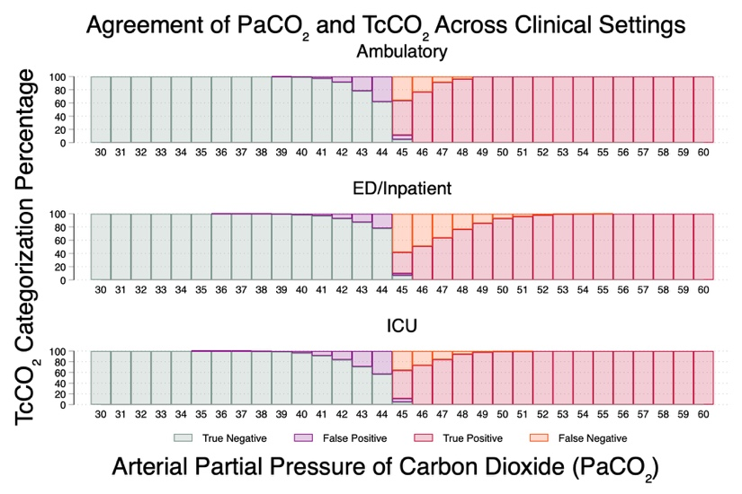

References

1. Konishi M, Akiyama E, Suzuki H, et al. Hypercapnia in patients with acute heart failure. ESC Heart Fail. 2015;2(1):12-19. doi:10.1002/ehf2.12023
2. Nin N, Muriel A, Peñuelas O, et al. Severe hypercapnia and outcome of mechanically ventilated patients with moderate or severe acute respiratory distress syndrome. Intensive Care Med. 2017;43(2):200-208. doi:10.1007/s00134-016-4611-1
3. Wilson MW, Labaki WW, Choi PJ. Mortality and Healthcare Use of Patients with Compensated Hypercapnia. Ann Am Thorac Soc. 18(12):2027-2032. doi:10.1513/AnnalsATS.202009-1197OC
4. Fazekas AS, Aboulghaith M, Kriz RC, et al. Long-term outcomes after acute hypercapnic COPD exacerbation : First-ever episode of non-invasive ventilation. Wien Klin Wochenschr. 2018;130(19-20):561-568. doi:10.1007/s00508-018-1364-6
5. Tiruvoipati R, Pilcher D, Buscher H, Botha J, Bailey M. Effects of Hypercapnia and Hypercapnic Acidosis on Hospital Mortality in Mechanically Ventilated Patients. Crit Care Med. 2017;45(7):e649-e656. doi:10.1097/CCM.0000000000002332
6. Locke BW, Richards WW, Gouripeddi R, et al. The Consistency of Hypercapnic Respiratory Failure Case Definitions in Electronic Health Record Data. Chest. Published online August 28, 2025:S0012-3692(25)05126-8. doi:10.1016/j.chest.2025.08.002
7. Baptistella CDPA, Mendes C de A, Silva MJ, Wolosker N. Retrospective Observational Single-Center Study of Complications of Arterial Indwelling Catheters for Invasive Blood Pressure in Intensive Care Unit Patients. Angiology. 2022;73(5):431-437. doi:10.1177/00033197211052127
8. Scheer B, Perel A, Pfeiffer UJ. Clinical review: complications and risk factors of peripheral arterial catheters used for haemodynamic monitoring in anaesthesia and intensive care medicine. Crit Care Lond Engl. 2002;6(3):199-204. doi:10.1186/cc1489
9. Farenden S, Chung Y, Cui A, Ferguson I. Prospective, observational study investigating the level of agreement between transcutaneous and invasive carbon dioxide measurements in critically ill emergency department patients. Emerg Med J EMJ. 2023;40(9):646-650. doi:10.1136/emermed-2022-212465
10.Conway A, Tipton E, Liu WH, et al. Accuracy and precision of transcutaneous carbon dioxide monitoring: a systematic review and meta-analysis. Thorax. 2019;74(2):157-163. doi:10.1136/thoraxjnl-2017-211466
11.Restrepo RD, Hirst KR, Wittnebel L, Wettstein R. AARC Clinical Practice Guideline: Transcutaneous Monitoring of Carbon Dioxide and Oxygen: 2012. Respir Care. 2012;57(11):1955-1962. doi:10.4187/respcare.02011

